**Insurance Risk Analysis**

**Problem Statement:**

In a one-click shopping world with on-demand everything, the life insurance application process is antiquated. Customers provide extensive information to identify risk classification and eligibility, including scheduling medical exams, a process that takes an average of 30 days.

The result? People are turned off. That’s why only 40% of U.S. households own individual life insurance. Prudential wants to make it quicker and less labor intensive for new and existing customers to get a quote while maintaining privacy boundaries.

By developing a predictive model that accurately classifies risk using a more automated approach, you can greatly impact public perception of the insurance industry.

**Data:**

In this dataset, you are provided over a hundred variables describing attributes of life insurance applicants. The task is to predict the "Response" variable for each Id in the test set. "Response" is an ordinal measure of risk that has 8 levels.

|  |  |
| --- | --- |
| Variable | Description |
| Id | A unique identifier associated with an application. |
| Product_Info_1-7 | A set of normalized variables relating to the product applied for |
| Ins_Age | Normalized age of applicant |
| Ht | Normalized height of applicant |
| Wt | Normalized weight of applicant |
| BMI | Normalized BMI of applicant |
| Employment_Info_1-6 | A set of normalized variables relating to the employment history of the applicant. |
| InsuredInfo_1-6 | A set of normalized variables providing information about the applicant. |
| Insurance_History_1-9 | A set of normalized variables relating to the insurance history of the applicant. |
| Family_Hist_1-5 | A set of normalized variables relating to the family history of the applicant. |
| Medical_History_1-41 | A set of normalized variables relating to the medical history of the applicant. |
| Medical_Keyword_1-48 | A set of dummy variables relating to the presence of/absence of a medical keyword being associated with the application. |
| Response | This is the target variable, an ordinal variable relating to the final decision associated with an application |

**The following variables are all categorical (nominal):**

Product_Info_1, Product_Info_2, Product_Info_3, Product_Info_5, Product_Info_6, Product_Info_7, Employment_Info_2, Employment_Info_3, Employment_Info_5, InsuredInfo_1, InsuredInfo_2, InsuredInfo_3, InsuredInfo_4, InsuredInfo_5, InsuredInfo_6, InsuredInfo_7, Insurance_History_1, Insurance_History_2, Insurance_History_3, Insurance_History_4, Insurance_History_7, Insurance_History_8, Insurance_History_9, Family_Hist_1, Medical_History_2, Medical_History_3, Medical_History_4, Medical_History_5, Medical_History_6, Medical_History_7, Medical_History_8, Medical_History_9, Medical_History_11, Medical_History_12, Medical_History_13, Medical_History_14, Medical_History_16, Medical_History_17, Medical_History_18, Medical_History_19, Medical_History_20, Medical_History_21, Medical_History_22, Medical_History_23, Medical_History_25, Medical_History_26, Medical_History_27, Medical_History_28, Medical_History_29, Medical_History_30, Medical_History_31, Medical_History_33, Medical_History_34, Medical_History_35, Medical_History_36, Medical_History_37, Medical_History_38, Medical_History_39, Medical_History_40, Medical_History_41

The following variables are continuous:

Product_Info_4, Ins_Age, Ht, Wt, BMI, Employment_Info_1, Employment_Info_4, Employment_Info_6, Insurance_History_5, Family_Hist_2, Family_Hist_3, Family_Hist_4, Family_Hist_5

**Solution:**

After the pre-processing and feature engineering of the raw data we have worked on the feature importance and received the following graph.

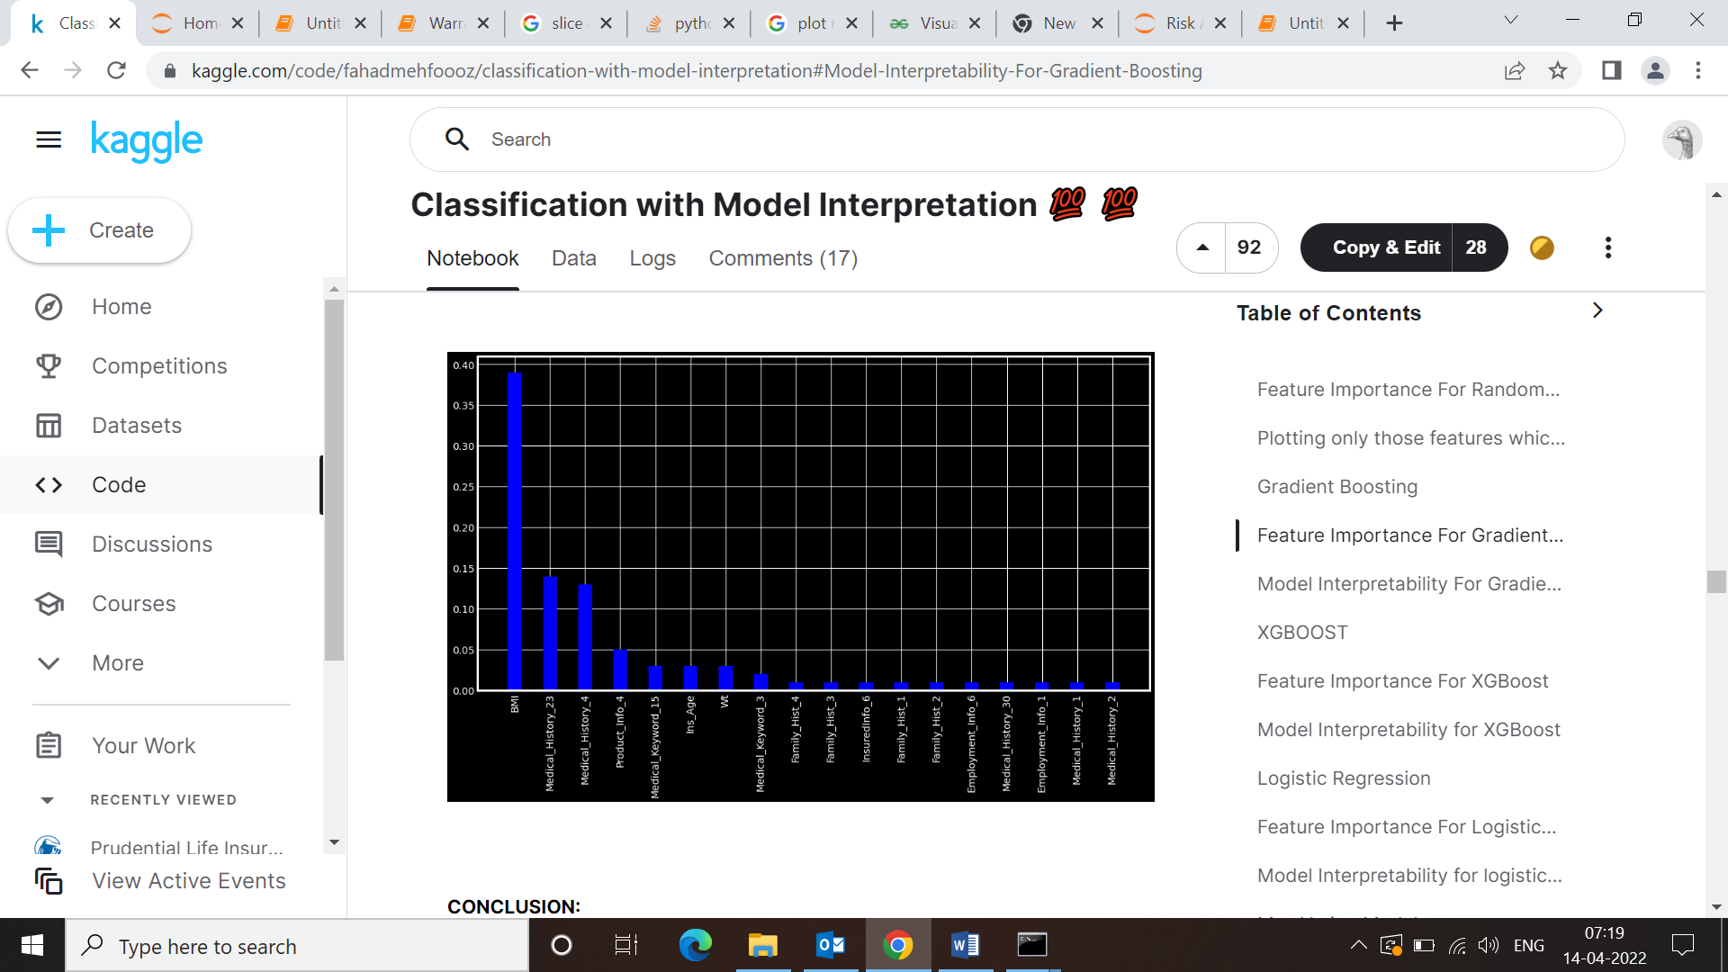

We have built a ML solution by taking the important feature in consideration and tried of several algorithm out of which XG Boot seems to be working most efficiently and gives and accuracy of 78 % . The accuracy level has been calculated for the available test data and there are high chances of improvement in near future.

Apart from this we have also used Lime algorithm to provide support each of predictions ie magnitude and direction the features which are leading to the particular results.